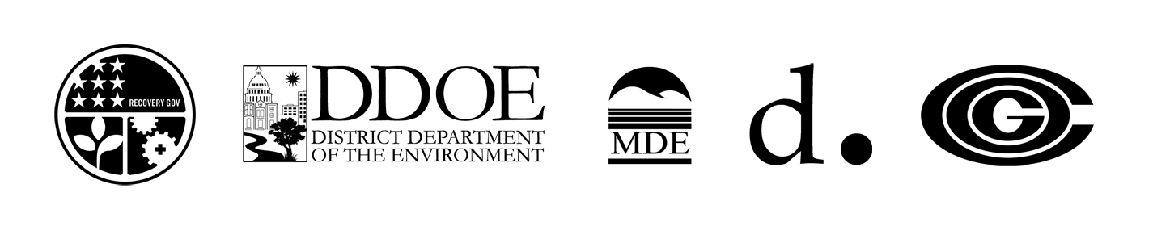

Release Date: June 23, 2010
Contact: Kristin Poe
Phone: 301 272 2413

Regional Diesel Idle Reduction Campaign Supported By Truck, Bus Sectors to
Begin in July

Washington, D.C. - Supported by the bus and trucking sectors, diesel idle reduction campaign will kick off July 13 and continue throughout the summer in the Metropolitan Washington-Baltimore Regions. The effort aims at decreasing diesel emissions and improving air quality for everyone.

The Metropolitan Washington Council of Governments (COG), in collaboration with the District Department of the Environment (DDOE), the District Department of Transportation (DDOT) and the Maryland Department of the Environment (MDE), is launching the idle reduction campaign to:

- Increase idle reduction awareness and control diesel emissions.
- Promote idle-reduction as a positive behavior that helps bus and truck drivers to avoid fines, save money, and cut fuel costs.
- Improve public health, protect the environment and enhance the quality of life for residents and visitors to our Nation’s Capitol and the Baltimore region.

“Turning the engine off when it doesn’t need to be on is one of the easiest and most efficient steps bus and truck drivers can take to help improve the region’s air quality,” said Leta Mach, Chair, Metropolitan Washington Air Quality Committee. “This simple act will help drivers to avoid costly fines, save money and curb fuel use.”

–more—

Diesel Idle Reduction Campaign Page 2

Bus and trucking associations and their member companies are actively supporting the idle reduction campaign, including:

- American Bus Association
- United Motor Coach Association
- American Trucking Associations
- Diesel Technology Forum
- Maryland Motor Truck Association
- National Association of Truckstop Operators
- National Private Truck Council
- Owner Operator Independent Drivers Association
- Truckload Carriers Association
- Virginia Trucking Association

Participating associations are reaching out to member bus and truck companies, encouraging them to inform their drivers about the idle reduction campaign and its positive benefits.

A news conference officially launching the 2010 Diesel Idle Reduction Campaign is planned for Tuesday, July 13 at 11:00 a.m. at Metropolitan Washington COG, Suite 300,
777 North Capitol Street, NE, Washington, DC 20002.

###

